logo.png

Inclusive Innovation Hub Testing Results

Raphael Alampay

**Objective**

The main objective of the testing is to test the usability of agreed additional features and changes of the Inclusive Innovation Hub. Based on the memorandum of agreement between Ateneo School of Government and the Department of Information Systems and Computer Sciencethe specific features are:

1. Popular Contributions (Most Viewed Contributions to be featured in the homepage)
2. Additional image resource to be contributed by contributors
3. PDF upload of syllabus
4. Creation of lesson unattached to a particular course
5. Social network sharing buttons
6. Contributor’s Module (Separate registration and profile for institutions and individuals)
7. Design implementation (from approved layout of the Hub’s user interface designer)
8. Ease of use of adding new content/article
9. Integration of RSS from external websites (Linking external websites to the platform)

**Participants**

The targeted participants of the testing are the existing institutional partners for the Inclusive Innovation Hub, and representatives of UNIID-SEA that comprises of:

1. Ms. Constance Camille S. Chua, Ateneo de Manila University
2. Dr. Iding Chaidir, Dewan Riset Nacional
3. Mr. Gerry Petilla, National Research Council of the Philippines
4. Ms. Charuwan Pharksuwan, National Research Council of Thailand
5. Ms. Dana de Guzman, UNIID-SEA
6. Ms. Tez Cruz, UNIID-SEA
7. Mr. Miguel Robleza, UNIID-SEA

**Method**

From July to October, 2014 the Inclusive Innovation Hub was introduced to UNIID-SEA partners for them to register and upload their institutional materials. Their feedback was collected in preparation of the final revision of the platform. Representatives from Ateneo, NRCP, and UNIID-SEA emailed their feedback. DRN requested for UNIID-SEA to register and upload for their institution. There was no response received from the NRCT.

Separate and joint meetings with UNIID-SEA representatives, Dana de Guzman and Miguel Robleza were conducted once or twice a month for direct instructions for platform revisions based on the agreed contract.

**Testing Results**

The following features has been successfully coded and integrated in the Inclusive Innovation Hub. For verification, please visit the site’s URL: [www.inclusiveinnovationhub.org](http://www.inclusiveinnovationhub.org).

1. Popular Contributions (Most Viewed Contributions to be featured in the homepage)
2. Additional image resource to be contributed by contributors
3. PDF upload of syllabus
4. Creation of lesson unattached to a particular course
5. Social network sharing buttons
6. Contributor’s Module (Separate registration and profile for institutions and individuals)
7. Design implementation (from approved layout of the Hub’s user interface designer)
8. Ease of use of adding new content/article
9. Integration of RSS from external websites (Linking external websites to the platform)

Listed below are the specific comments from the participants that I addressed in the improvement of the platform.

**Constance Camille S. Chua**

**August 15, 2014**

1. We have encountered some error while trying to upload an article to the Inclusive Innovation Hub. (Attached is the error)

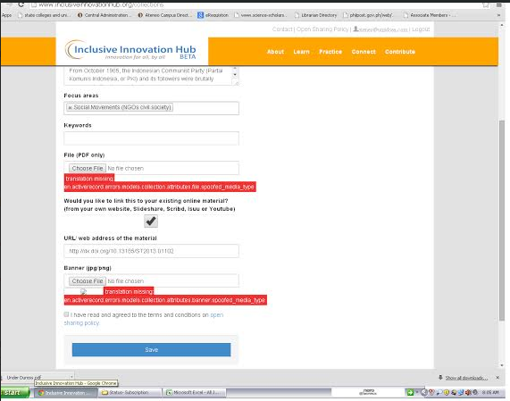

**2.** I have uploaded 3 articles from Social transformation Vol. 1 , No. 1 (2013) as listed below. However, they are not showing in the site.

a. [Under Duress: Suppressing and Recovering Memories of the Indonesian Sixties](http://journals.ateneo.edu/ojs/index.php/ST/article/view/ST2013.01102) by *Vannessa Hearman*

*b.* [*“Subaltern” Remembrances: Mapping Affective Approaches to Partition Memory*](http://journals.ateneo.edu/ojs/index.php/ST/article/view/ST2013.01103)*by Jacque Micieli-Voutsinas*

*c.*[*Counteractive Strategies in Colonial and Postcolonial Narratives of Memory: Joseph Conrad’s Heart of Darkness and Anita Desai’s Clear Light of Day*](http://journals.ateneo.edu/ojs/index.php/ST/article/view/ST2013.01104)*by Rizwan Akhtar*

**Tez Cruz, UNIID-SEA**

**September 22, 2014**

Here are the difficulties I encountered:

1. My account (kay Dr. Hui Min Low talaga) keeps logging out every time I edit my profile and after registration. Frustrating sya kasi I have to re-upload Dr. Hui Min's photo. Di kasi indicated na 250x250 yung size kaya putol yung ulo nya nung una kong upload. I have to resize pa in Photoshop. Maybe pwedeng ayusin yung positioning ng photo sa mismong site?

2. Same photo issue on the "main picture" requirement sa course. I have to resize in Photoshop because the site cropped my initial photo. Cropping is okay naman pero sana may user control.

3. Nadodoble yung naka-input sa objectives when you try to view the course. No way around it. Please look: <http://www.inclusiveinnovationhub.com/courses/9>

Immediately after ng **Objectives,** may **Introduction** part, which is only a clone of the Objectives part. I didn't input any Introduction dahil wala namang box for that. Meron ba dapat? (I think meron)

4. If I follow yung course outline, minimal lang talaga ang maka-copy paste without the actual module: title, objectives, and a short description to each lesson. Other boxes need attachments. We need to upload the PDF file if we you want it to look complete sa regional conference. Another consideration is we might want to ask Julie for separate PDFs per lesson and another PDF for the whole course/module.

5. While I'm using the site, the following page appeared when I tried to click on any link:

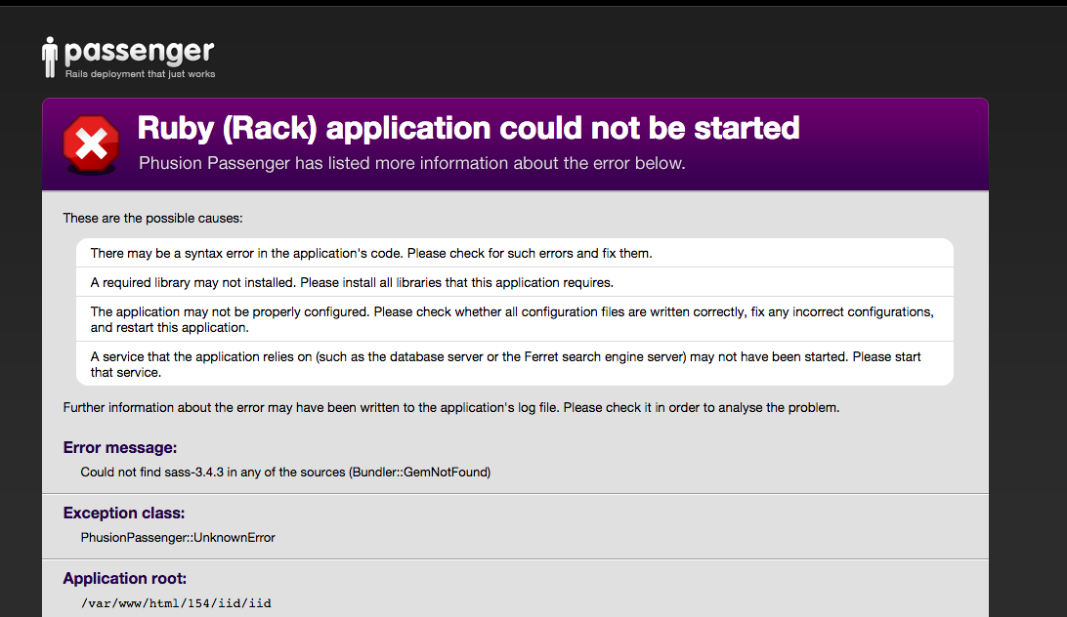

6. Baka kailangan ng word limit sa Course Description. Nung una kasi nag-copy paste lang ako ng mahabang intro from the module, tapos nakita ko na ang pangit dito: <http://www.inclusiveinnovationhub.com/courses> kaya iniklian ko.

7. Baka pwedeng liitan yung font ng titles sa thumbnail on this part kasi di naman mabasa ng buo kung ano yung naka-link. (e.g., Teacher Training Modu..., Curriculum Design and...., More than Just a Sip: The E...)

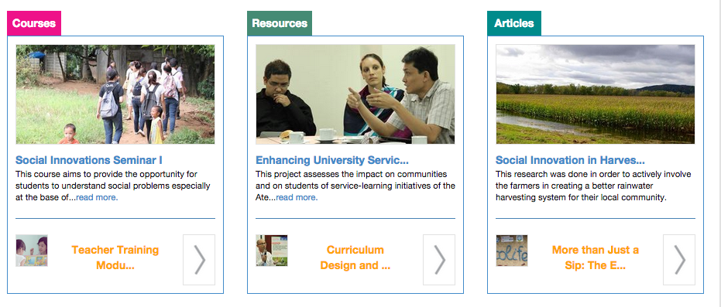

**Dana de Guzman**

**August 1, 2014**

1. Remind ko lang yung updating to the new design ng

- [www.inclusiveinnovationhub.com](http://www.inclusiveinnovationhub.com)

- [www.inclusiveinnovationhub.org](http://www.inclusiveinnovationhub.org)

2. at yung documents para sa 2nd tranche mo

- testing results (our internal testing result should be fine)

- user's manual

- admin's manual

3. at so far, after testing the hub yung concern pa lang for revision ay yung usability ng side bar sa learn (see photo)

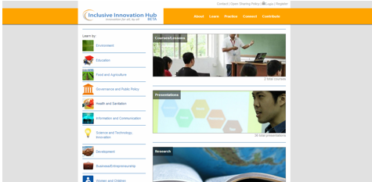

4. Error Sign: Pag maglilink ng website, required pa rin maglagay ng PDF file.  Supposedly url lang ng website ilalagay hindi na PDF file

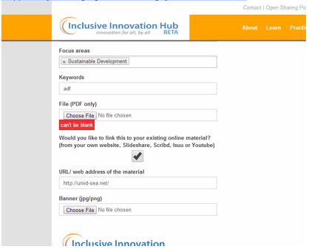

5. pwede bang pagtinype yung .com magfoforward na siya sa .org site and domain name?

6. para lang masimulate mo, ayaw magupload ng file na ito. actually dinownload ko ito galing sa hub.

7. at hindi ko rin mapalitan yung photo/banner na nakaupload na per material.

**Miguel Robleza**

**August 11**

Homepage:

-sizes ng mga boxes(COURSES,RESOURCES,ARTICLES) (masyadong malaki padin yung space sa gitna ng 3 box)

-arrows and text for the boxes not in the center and please remove the outline of the arrow. text (please make the font smaller)

-slider

-log in / register button on the right side

Learn:

-paki liitan ang icons nito

Practice and Connect:

-papalitan nalag nito ng diffrent animated dropdown

**Dana de Guzman**

**Oct.14, 2014**

1. About (yung ngayon kasi may “vari-ous” na hindi dapa ☺)
2. Pwede ba pag may naghover-over sa medal may lalabas na description, gaya ng sa baba? :)

**CONNECT PAGE**

1. Homepage - Extra request :) paki-lakihan yung space ng text at align yung yung arrow para masmabasa yung content.

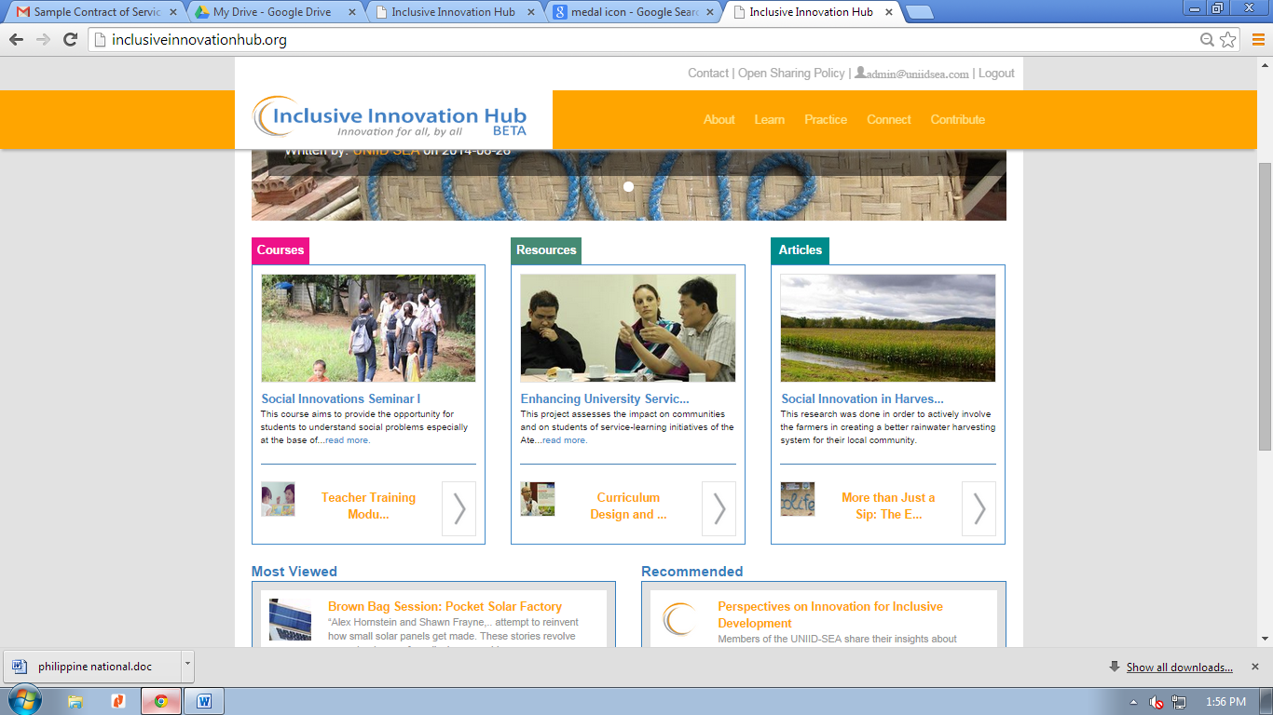

1. Remove password option when user is editing the profile details. Kindly move it to another page.
2. **LESSON –** hindi viewable yung links to assignments, primary readings, secondary readings, exams

**From this page**

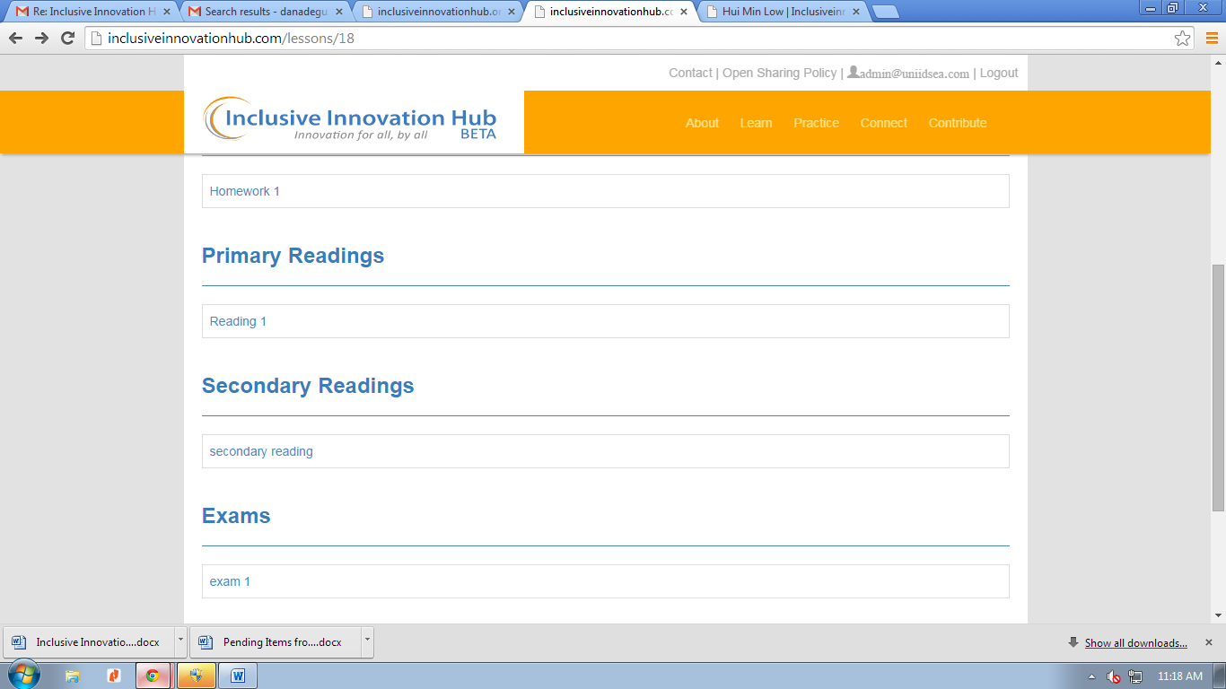

**To this page**

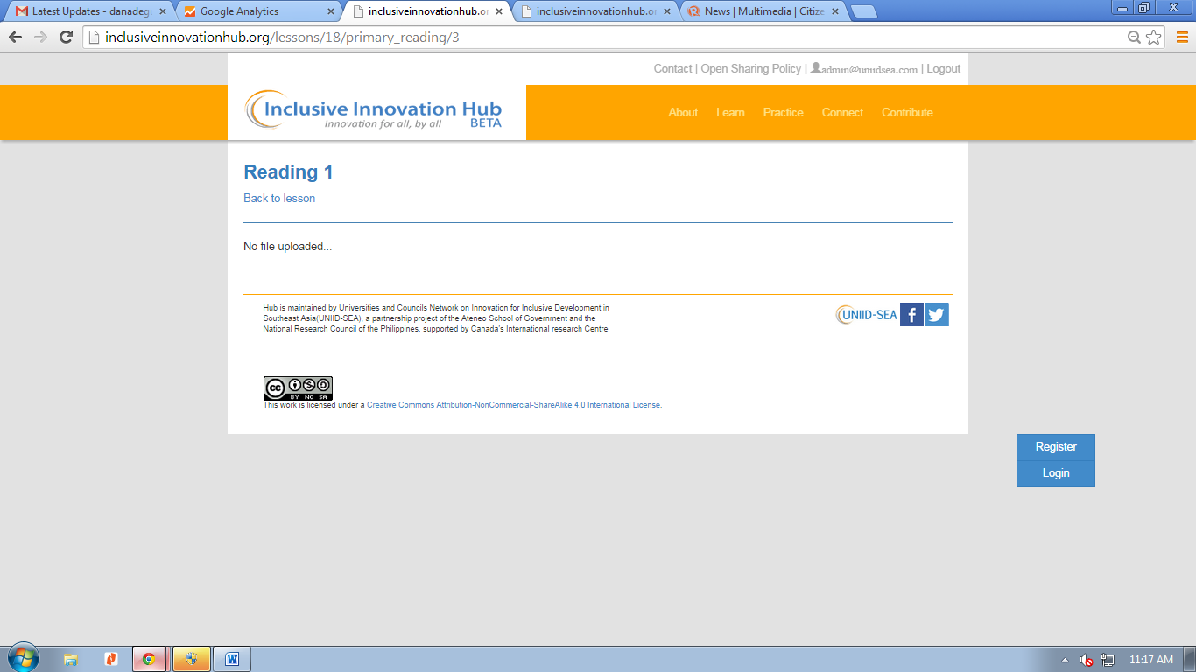

2. LESSON COURSE pala - Kindly remove intro in the intro view

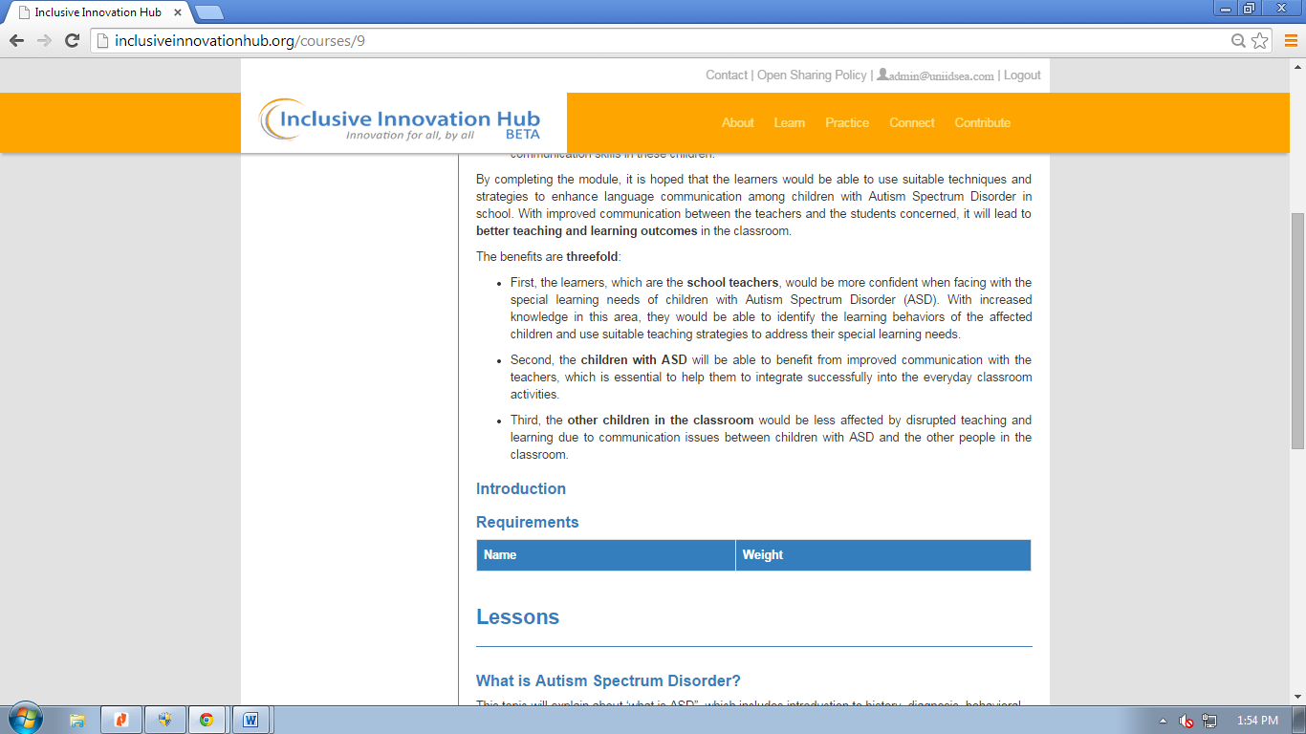

3. reminder on .com 🡪 .org – okay sana sa Friday kaya na? kalian kaya?

:Picture 10.png

4. FORMS - indicate **size & dimesion** of photos for profile photo and banner photo

5. get and upload random pattern from Miguel for the automatic banner photos – PARK THIS

6. LEARN – Keyword search button is not working

7. CONNECT – explanation shows when arrow hovers over the medal

8. SIDE BARS- lessen spacing/padding

9. SIDE BARS – make lines consistent. Make it very light gray (not blue)

10. LISTS – kindly make it 20 a page

11. LISTS – kindly remove “posted on DATA”. Keep it in the article, not the list ☺

12. PROFILE – ALL TYPES OF MATERIALS – remove download option

13. PROFILE – ALL TYPES OF MATERIALS – align left “view” button, change color to blue. Specifically sa Courses at sa Videos. Paki review yung consistency ng margins nito. Iba-iba yung course, article, presentation, research, books, videos, at lesson

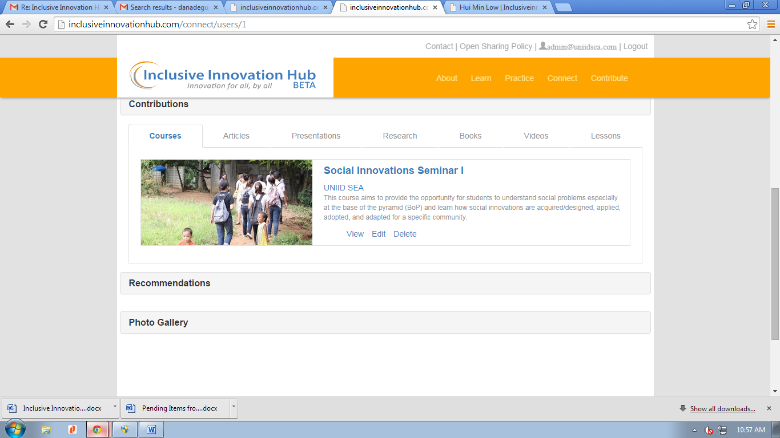

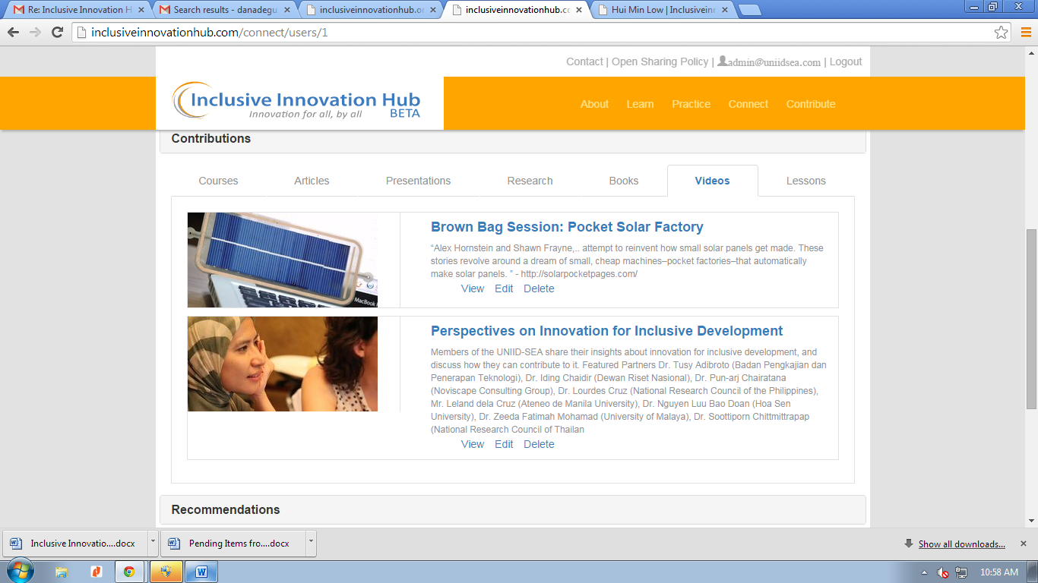

14. LESSON - remove “overview” in the text

15. LESSON FORM- insert “content” in the form, but don’t show the text “content” when user is viewing the lesson.

16. INSTALL Google Analystics please ☺ Can you give me instructions on how to check? (username password/ or can I check it from my email account?) As advised here’s the tracking ID

17. BANNER Please remove author and date of post in the banner

18. BANNER Place the text and the see thru box at the lower edge of the banner/photo

19. LESSONS/COURSES FORM- insert word limit in “description”. Pag-nag copy paste ng mahabang description, napuputol pag-binasa sa list view.

20. ARTICLE- remove co-author if there’s no co-author typed in

21. SIDEBAR- make blue line to super light gray. And add line on the left side of the side bar. Wala siya ngayon.

22. LESSON- lesson cannot be viewed. I cannot input new lessons too.

From here

23. PROFILE> EDIT BUTTON- kindly fix this layout

From

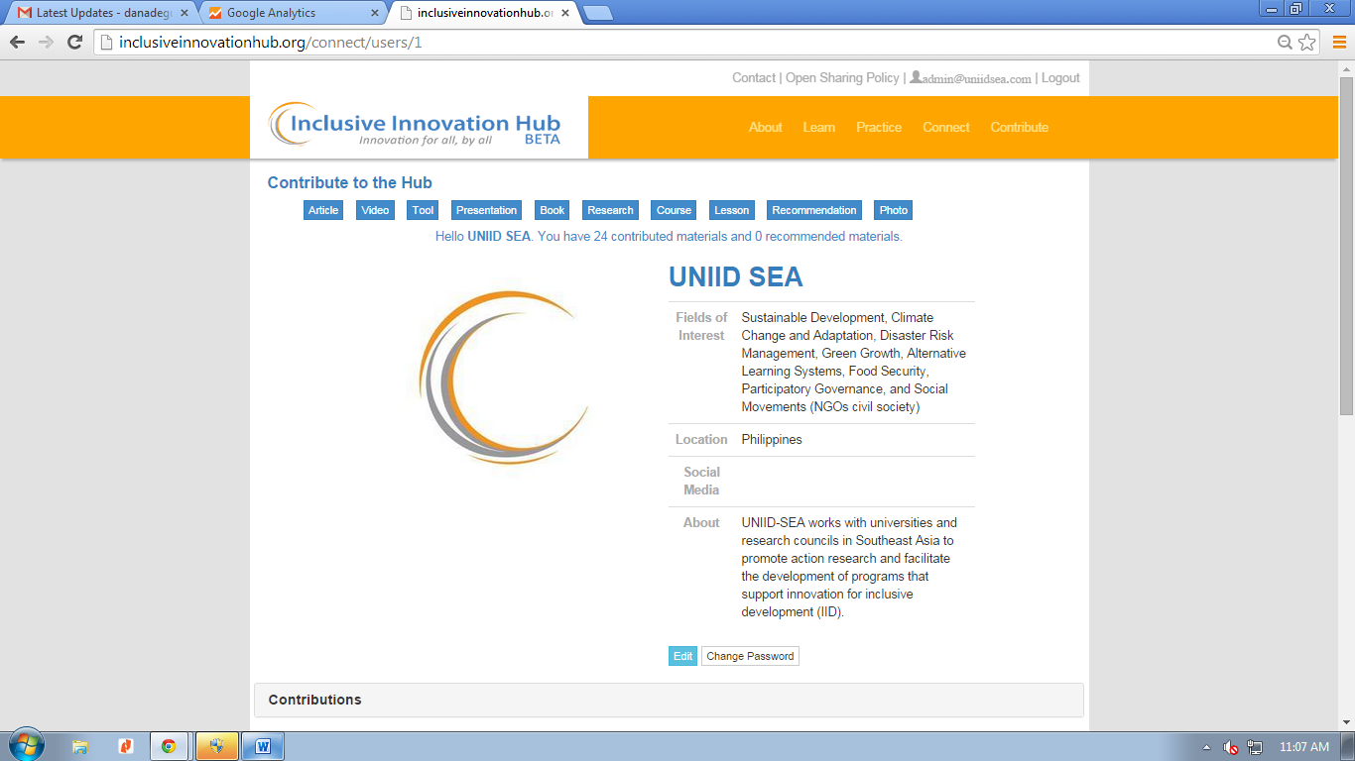

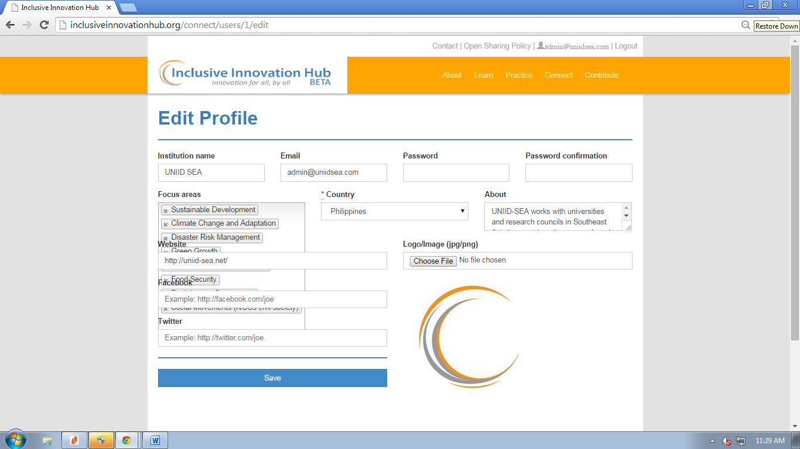

Change part-nerships to partnerships

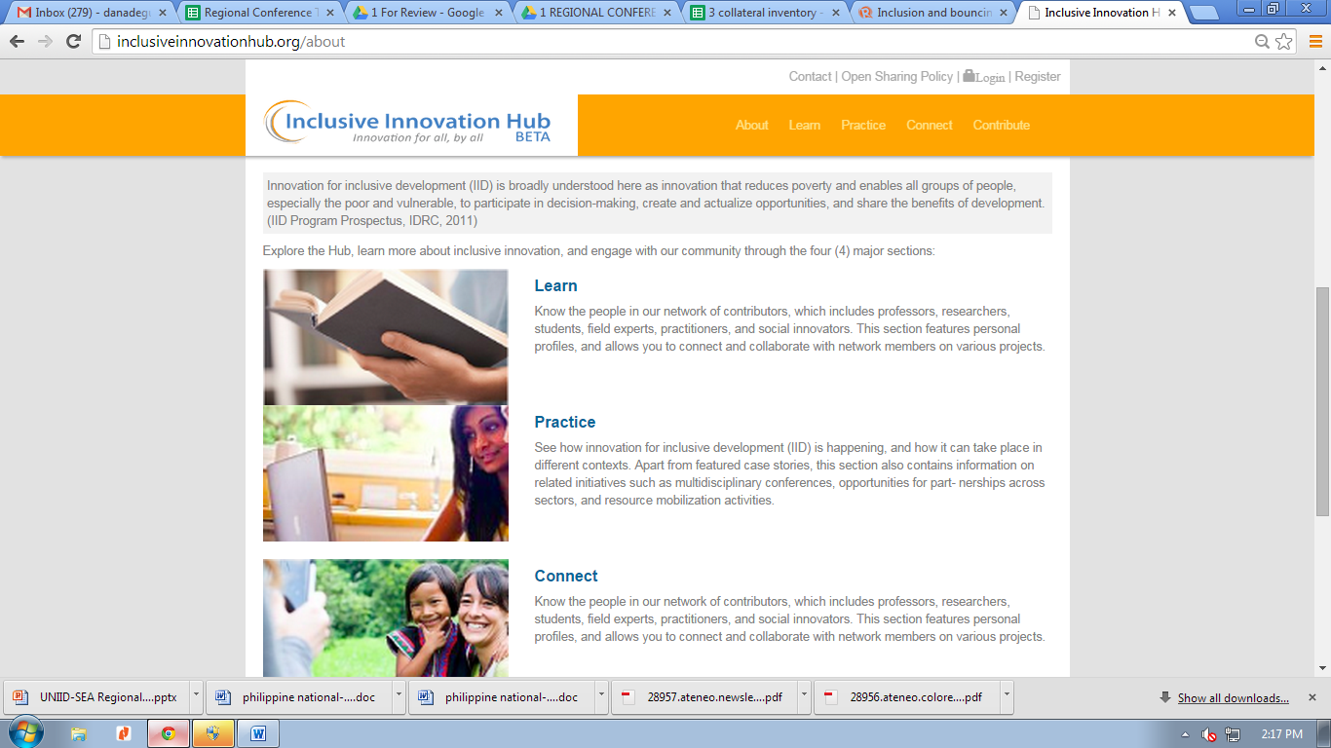

Paki-gawang consistent yung margins ng photo at text placement sa profile page

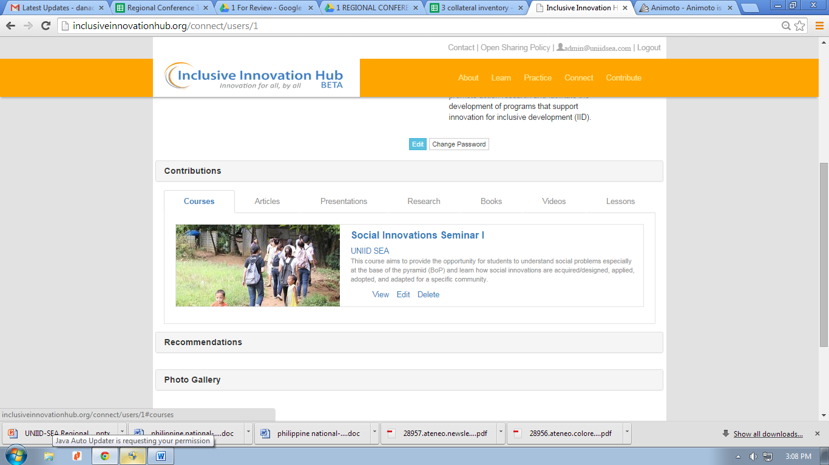

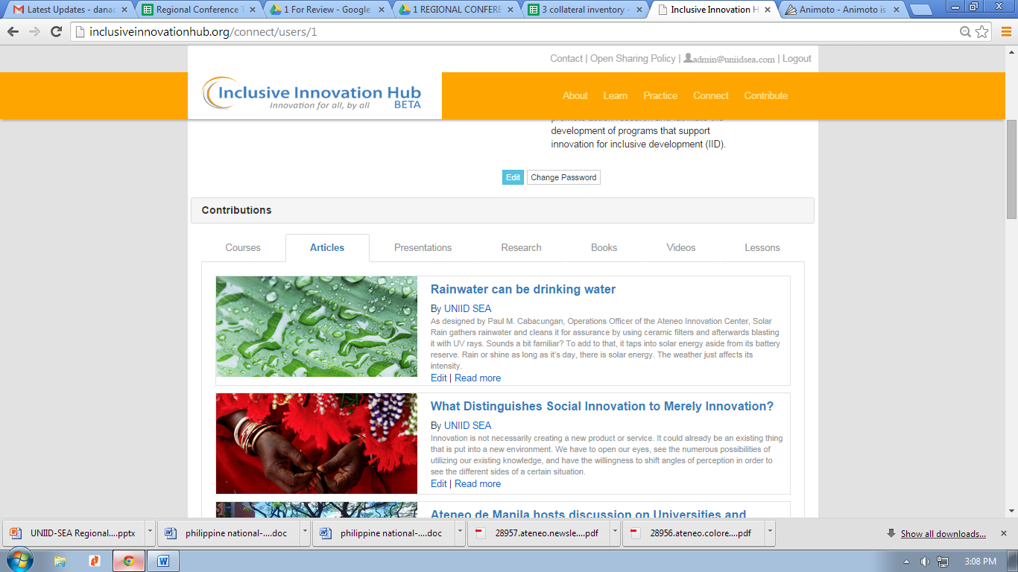

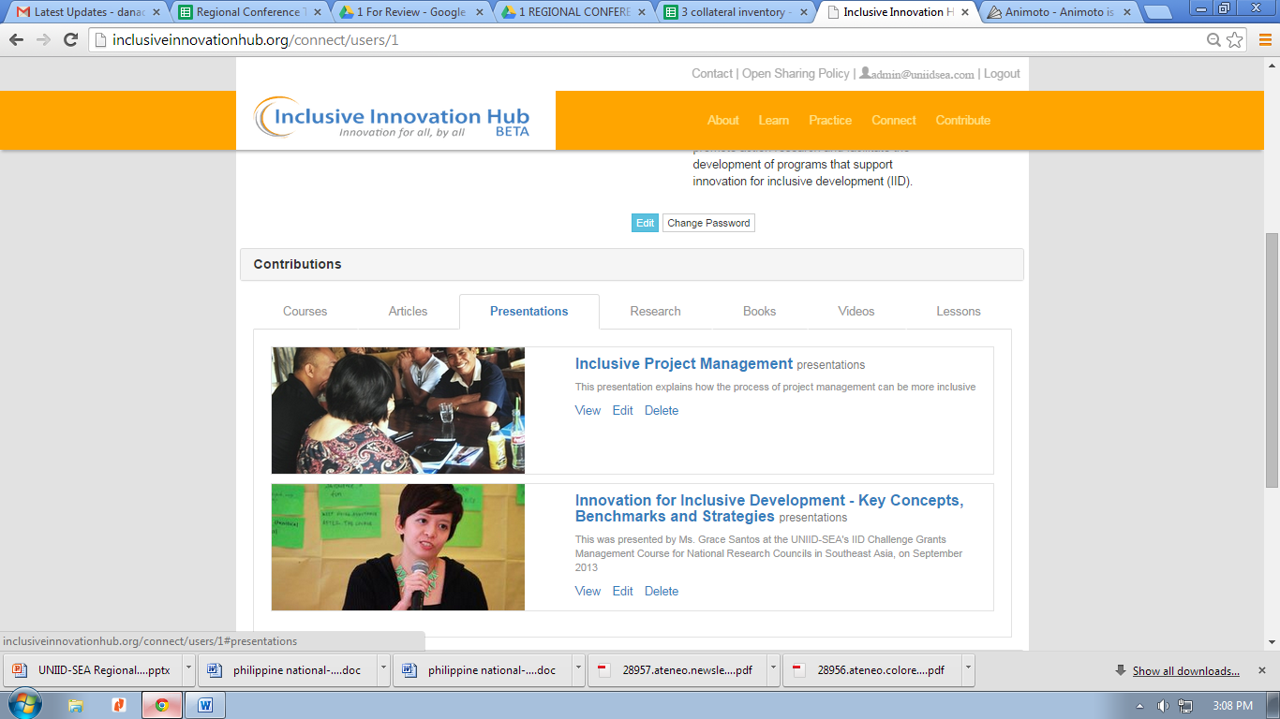

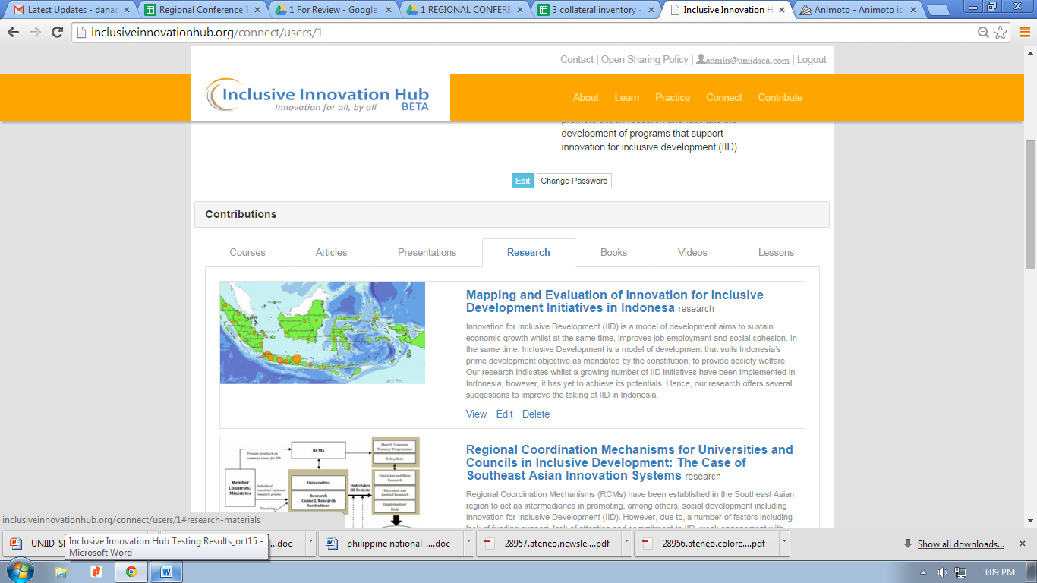

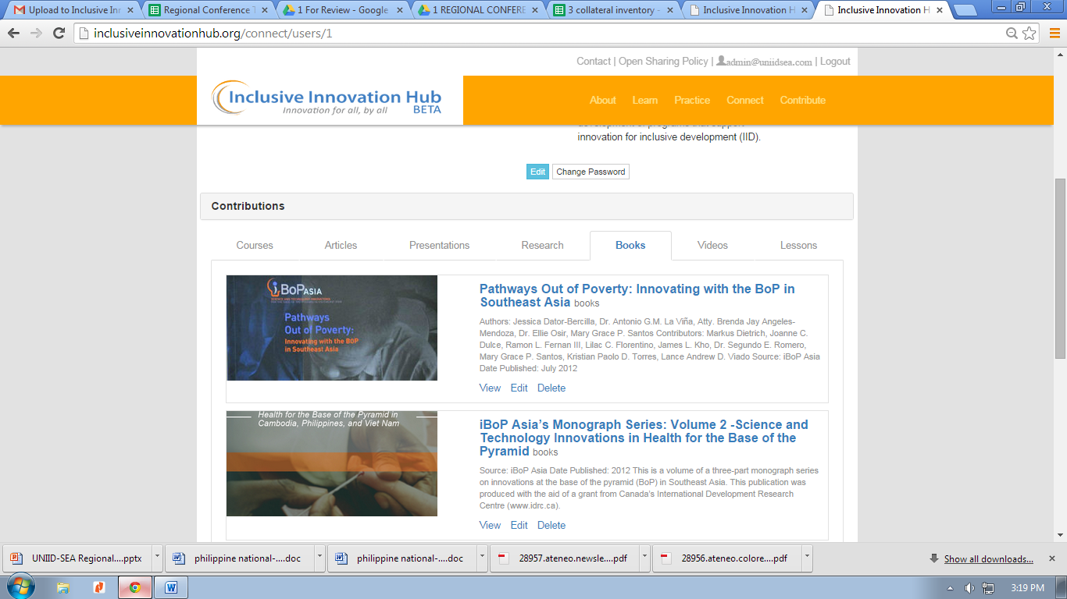

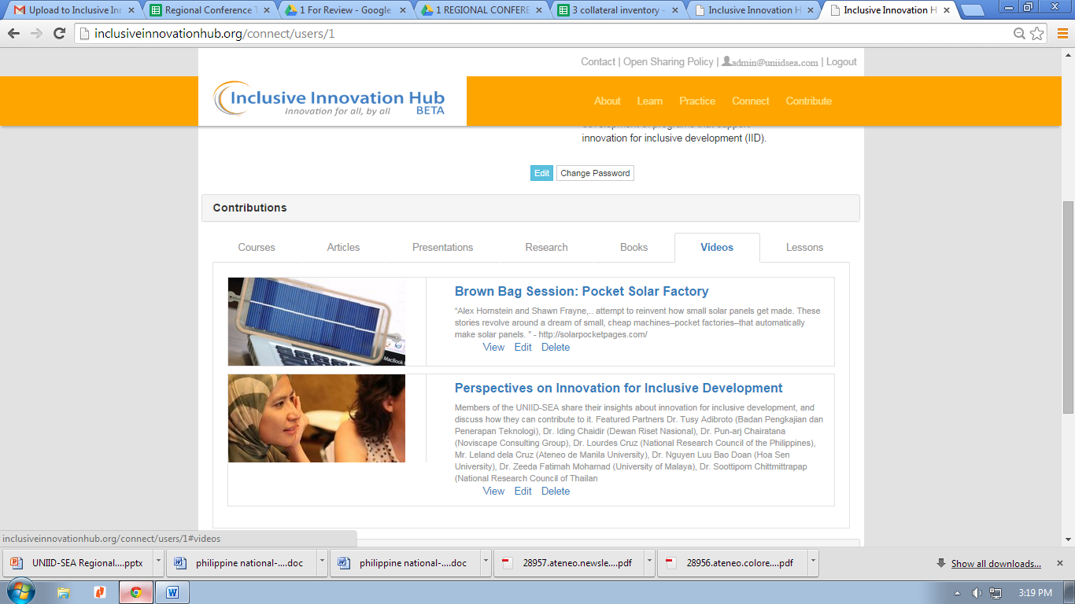

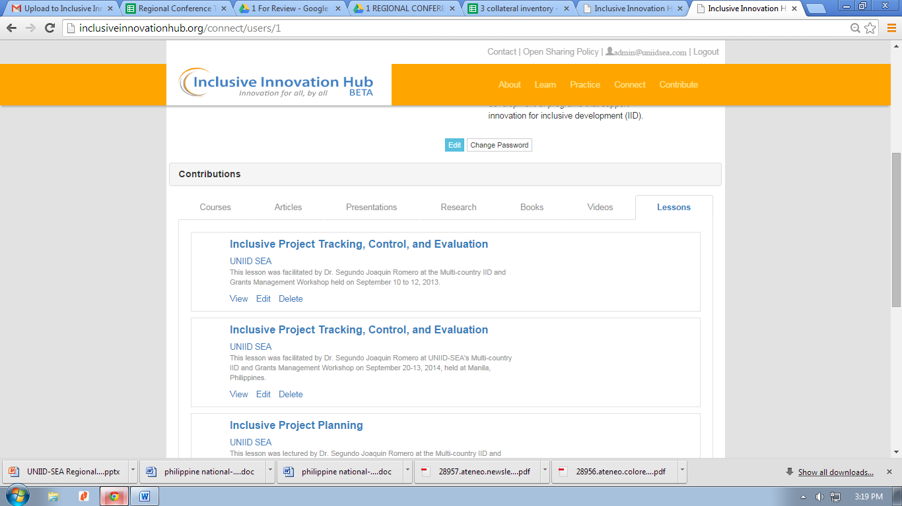

* Corrected vari-ous to various in about page
* Password is not showing when user is editing profile. This allows them to edit their profile without supplying the password. A user can edit his or her password by clicking the edit  password option (see attachment 1).
* Spacing for sidebar (see attachment 2)
* Lessons' contents (assignments and readings) can be viewable if they upload a file (see attachments 3-5).
* There is no intro in lesson view (see attachment 6) *– there in intro view in course view*
* Dimension labels for all banner resources (see attachment 7-8).
* User links aligned (see attachment 9). – *course and video not yet aligned*
* Added google analytics code (see attachment 10). Please check your analytics account accordingly.
* Word count limit label (see attachment 11)
* Light grey borders in sidebars (see attachment 13)
* For some older versions of browsers, selecting a lot of items in focus areas doesn't push down the content (see attachment 14) – *okay thanks :)*

Lesson

1. Kindly make the course code optional

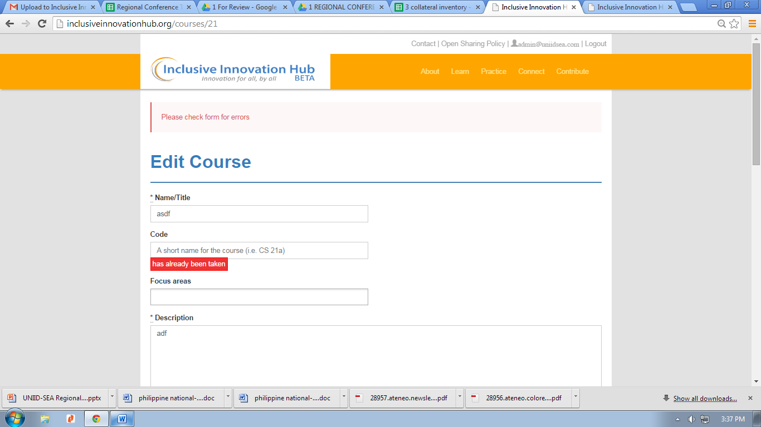

1. Hindi na maka-tanggal ng uploaded material (for reading, assignment, exam, etc), pag na-upload na.
2. Paki-edit yung text box ng description at objectives from

This

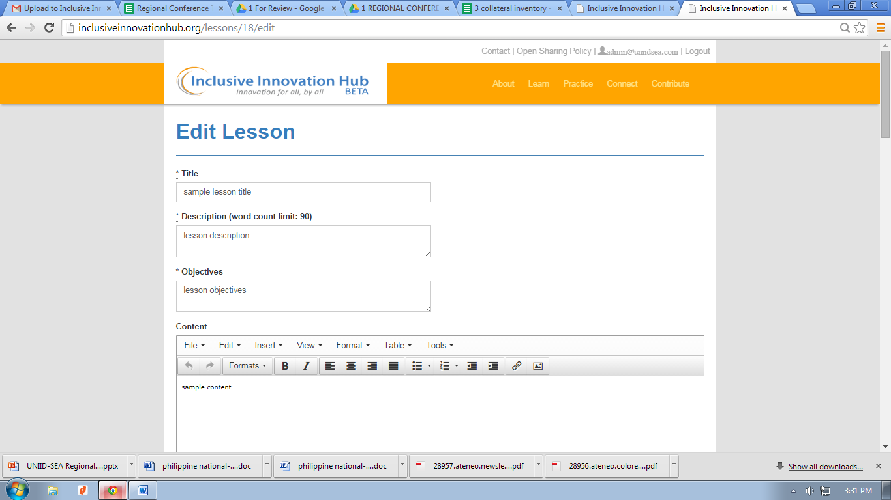

To This

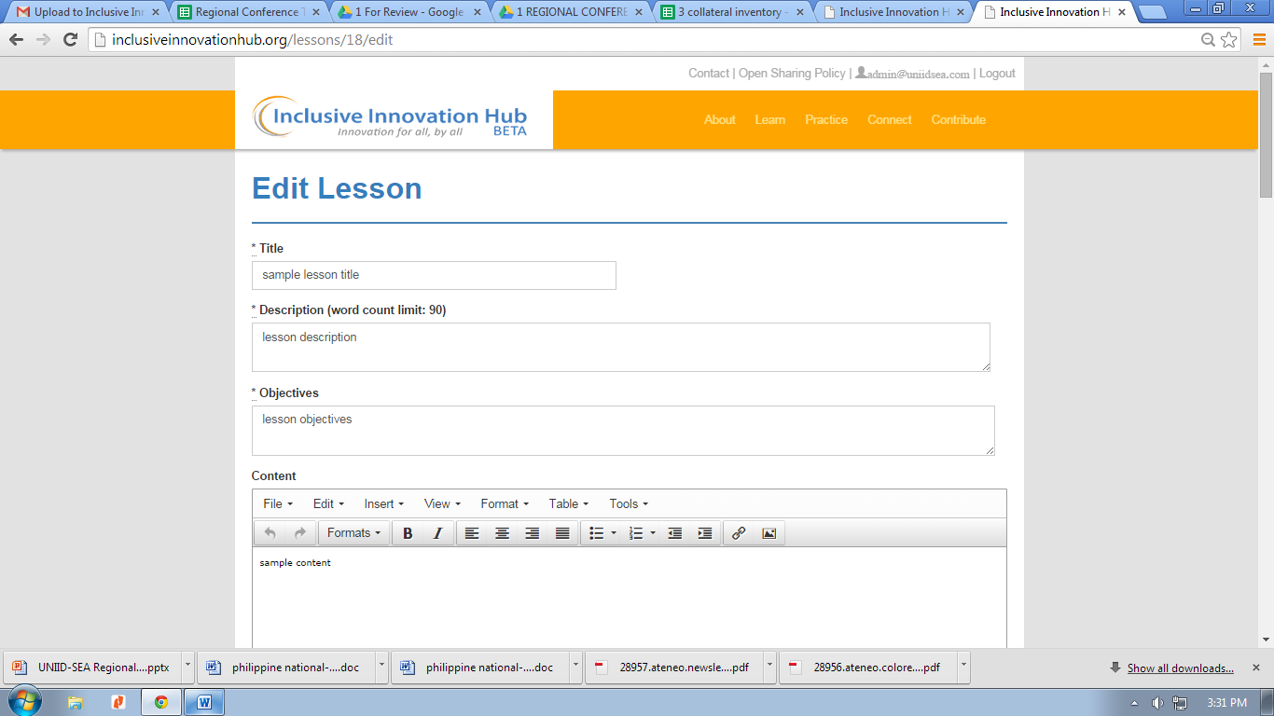

From this

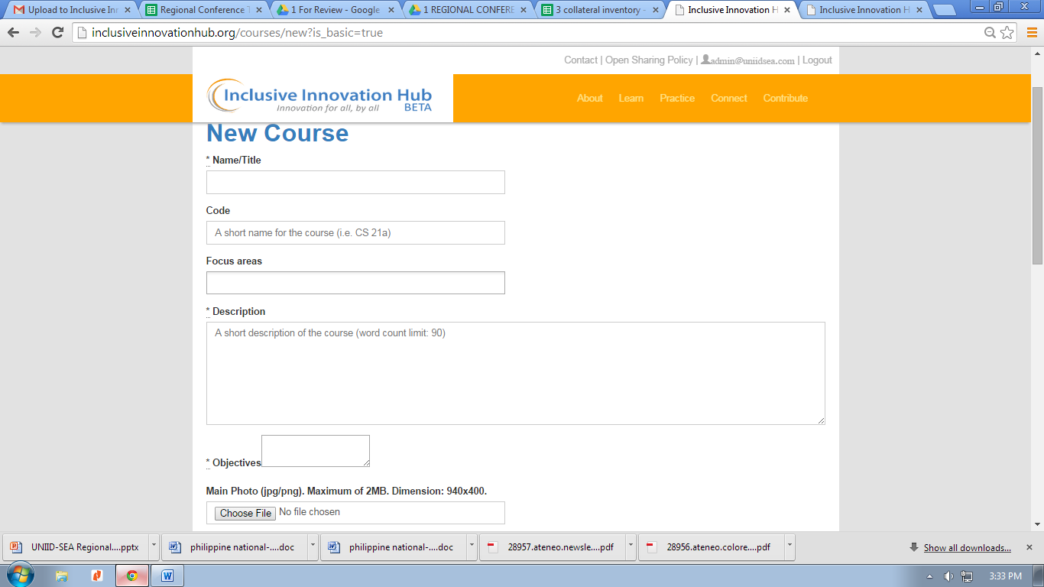

To as big as description box

1. pag walang naka upload/link, paki tanggal na sa view please

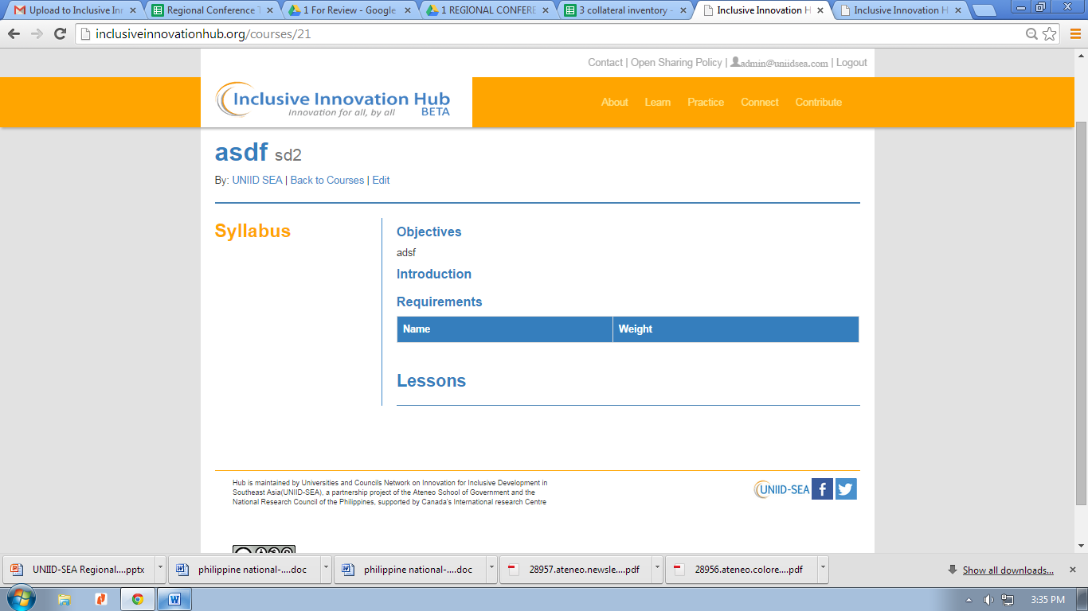

1. paki-dagdag yung “content” textbox sa course form

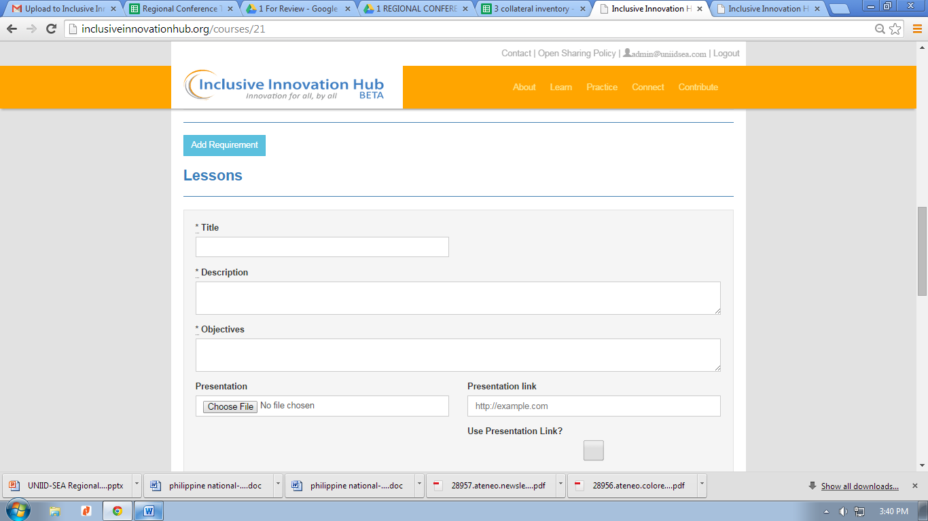

1. padagdag nung checkbox

**“ I have read and agreed to the terms and conditions on**[**open sharing policy**](http://inclusiveinnovationhub.org/policy)**.”**